Career Guidance System for Students Using Machine Learning-Based Skill and Interest Analysis
Mrs.K. Anusha, Adusumilli Yuva Venkat, Paleti Jayanth Kumar, Gentyala Vaishnavi
Assistant Professor CSM, CMR College Of Engineering & Technology, Hyderabad, Telangana, India
kunthan.anusha@cmrcet.ac.in
CSM, CMR College Of Engineering & Technology, Hyderabad, Telangana, India
22h51a6603@cmrcet.ac.in
CSM, CMR College Of Engineering & Technology, Hyderabad, Telangana, India
22h51a6645@cmrcet.ac.in
CSM, CMR College Of Engineering & Technology, Hyderabad, Telangana, India
23h55a6609@cmrcet.ac.in

ABSTRACT

One of the most crucial elements in the lives of students was career path selection and career choices were determined by various issues including information deficit, social pressures and other external factors. In cases where students chose the wrong career path, they were likely to feel lowly motivated and this had a negative impact on their performance in school and prospective areas of career. The objective of this project was to come up with a Career Guidance System among Students based on machine learning methods. The system gathered student related information of basic data, including academic performance, skills, interests, and aptitude. To enhance the accuracy and efficiency of the data, the obtained data were preprocessed and refined through feature selection algorithms. Machine learning algorithms were subsequently used to determine career areas that the students could suit in terms of their competencies and inclinations. The findings indicated that the system was able to align the unique student traits to the right career options, thus minimizing confusion in the career decision making process. The new system was supposed to be efficient, user friendly and scalable. A system like this might be extremely helpful to students and educators as it offers systematic and evidence-based career advice. Also, the system used machine learning methods with conventional career guidance methods to assist in a better-informed, skill-based decision-making process.
Keywords: Student Career Prediction, Career Guidance Intelligence, Career Recommendation Systems, Machine Learning Career Guidance, Skill Gap Analysis, Career Decision Support System, Student Career Analytics, Student Profiling, Predictive Modeling, Educational Data Mining, Ensemble Learning.

- INTRODUCTION

Lack of awareness, social pressure, dynamic industry demands, and absence of personalized guidance were some of the problems confronting students in identifying the right career choices. Most educational surveys suggest that almost 30-40 percent of students on obtaining appropriate career paths were not sure which ones to take, and more than half of all graduates believed that their major was not well aligned to their skills or interests. Moreover, research on employability showed that approximately 45 percent of graduates were not equipped with the necessary industry skills, which is the effect of insufficient career advice and poor decisions at the initial stages of academics.

The general career guidance services offered in educational institutions failed to take into account individual abilities, interests, skills, and academic performance. This made career choices among many students not to match their abilities and future aspirations that resulted in lack of motivation, satisfaction in learning activities and reduced chances of employability. Thus, there was a great necessity in the intelligent systems that could assist students in making data-driven and informed career choices.
The existing career guidance systems were mostly founded on aptitude tests, psychometric tests, and rule-based expert systems. These traditional systems assessed pre-decided aspects of logical reasoning ability, personality characteristics, and academic performance. Rule-based systems were based on pre-defined decision rules that mapped responses of students to particular career choices. These systems were structured to give career guidance and basic support although they were not flexible and adaptable. They could not handle big multidimensional data and keep up with fast changing career areas and industry requirements. Also, traditional systems were based on fixed rules that could not be personalized and minimized the precision of career forecasting.

Recent developments in the field of machine learning resulted in a massive change in the sphere of career guidance. The scholars used supervised and unsupervised machine learning methods to discover intricate patterns in student data. In a bid to offer personalized career advice, academic performance, skill sets, interest profiles, and behavioral patterns were analyzed using machine learning models, including Decision Tree, random forest, Support vector machine (SVM), K-Nearest Neighbor (KNN) and Neural networks. The latter were more adaptable and forecasting, since they adapted to past experience and enhanced their effectiveness with time, unlike hard and fast rule-based systems. Some of the studies claimed that machine learning-based career guidance systems were more accurate in the prediction and scalable than the traditional systems.

The available research studies however tended to concentrate on few qualities including academic performance or aptitude test score excluding other significant aspects like socio-economic background, skill gaps, and emerging industry trends. There were systems that served as black-box models where the students and career counselors could not easily comprehend the logic behind career advice. Moreover, most of the systems failed to handle the problems of fairness and transparency properly and their functionality was not frequently confirmed by practical user tests.

To address these drawbacks, this study suggested a Career Guidance Intelligence (CGI) model, which combined machine learning methods to provide dynamic and customized career advice. The CGI model gathered multidimensional data about students, such as academic history, technical expertise, soft expertise, aptitude test scores and interest trends. The data were preprocessed with the help of normalization and feature encoding methods and an ensemble learning method was used to improve the accuracy of prediction.

The proposed CGI model was adaptive to new careers and new industry needs in comparison to the existing systems and learnt dynamically through data. The model also used the feature importance analysis to give results that are interpretable so that the students and career advisors can know the rationale behind suggested career choices.

- RELATED WORK

Several research studies were conducted to identify effective solutions in the area of career guidance with the aim of assisting students in making informed career decisions. Early approaches relied on traditional techniques such as aptitude tests, psychometric assessments, expert systems, and basic data-driven analytical models. Aptitude tests and psychometric analysis were widely used to evaluate cognitive abilities, personality traits, and interest patterns, thereby providing a structured framework for career planning. Similarly, rule-based expert systems were developed to simulate human decision-making processes by applying predefined rules and criteria to student responses. These systems provided structured platforms for evaluating employability potential and guiding students toward appropriate academic or career paths.

However, despite their structured design, these traditional methods showed several methodological limitations. Rule-based systems were inflexible and non-adaptive because they relied on manually defined rules that could not dynamically adjust to diverse student profiles. Psychometric analysis, although useful, remained static and limited to predefined psychological constructs, which restricted the range of career recommendations. Furthermore, these systems struggled to handle high-dimensional student datasets and failed to incorporate evolving industry requirements or emerging career domains.

With the advancement of machine learning technologies, researchers introduced classification and predictive models to improve the effectiveness of career guidance systems. Machine learning algorithms such as Decision Trees, Random Forest, Support Vector Machines (SVM), and K-Nearest Neighbors (KNN) were applied to analyze student data and generate personalized career recommendations. These models demonstrated improved predictive performance by learning patterns from historical data.

Nevertheless, many existing machine learning approaches focused primarily on limited attributes, particularly academic performance records. Although these systems achieved acceptable levels of prediction accuracy, they ignored important factors such as personal interests, behavioral traits, and soft skills, which are critical for determining career suitability. Some systems attempted interest-based analysis, but they suffered from inadequate data preprocessing, poor feature selection techniques, and imbalanced datasets, which resulted in reduced prediction reliability.

In contrast, the proposed system integrates multiple attributes, including academic records, technical skills, soft skills, aptitude scores, and individual interests. Structured preprocessing techniques such as data normalization, feature encoding, and feature selection are applied to improve the quality of input data. By leveraging historical student data and ensemble learning techniques, the proposed approach overcomes key limitations of existing methods while ensuring higher prediction accuracy, adaptability, and personalized career recommendations.

Table I
Research Comparison Table

S.No | Title | Authors | Methodology | Limitations
1. | Career guidance system for students using machine learning | E. Padma, P. Sowdharshini, P. Shanmugapriya | Random Forest classifier applied to student academic records and aptitude scores | Small dataset causing possible overfitting
2. | AI-powered career guidance system using machine learning techniques | M. Reddy, P. Sharma | Supervised learning with ensemble models | Limited explainability; no real-world validation
3. | Smart career advisor: A machine learning-based recommendation system | S. Gupta, V. Mahajan | Decision Tree with similarity-based recommendation | Long-term performance not evaluated
4. | AI-driven career path prediction using classification algorithms | T. Iqbal, R. Khan, A. Hussain | Decision Tree, SVM, KNN on student profiles | Socio-economic factors not considered
5. | Personalized career recommendation system using hybrid approach | D. Mehta, K. S. Rao | Hybrid (content + collaborative filtering) | High computational complexity; large dataset required
6. | Machine learning-based intelligent career counseling system | R. Das, S. Banerjee, M. Roy | Naïve Bayes + KNN classifiers | Limited sample size affecting generalization
7. | Predictive analytics for student career mapping using ML | V. Kumar, P. Srivastava | Regression + classification | Only accuracy reported; fairness not analyzed
8. | AI-based decision support system for student career selection | H. Singh, N. Arora | Support Vector Machine (SVM) | Dataset imbalance not addressed
9. | Career recommendation using Random Forest and KNN | S. Choudhary, R. Mishra | Random Forest + KNN | Evaluation used limited performance metrics
10. | Fairnessaware ML framework for career recommendatio | A. Deshmukh, R. Kulkarni | Fairness constraints added to classifier | Fairness evaluation was preliminary

- METHODOLOGY

The suggested approach was to design a Career Guidance Intelligence (CGI) system based on machine learning approaches to provide students with personalized career advice. The system was a multidimensional student data in terms of academic performance, skills, interests and aptitude scores that forecasted appropriate career domains. The process involved data gathering, pre processing, feature engineering, model training, evaluation and generation of recommendations.

Dataset Description:

The data in this study was gathered via a questionnaire in the form of a survey that was carried out among undergraduate students in a technical institution. The sample size was 520 student records (N = 520) which had several attributes that were connected to academic performance, technical skills, personality traits, aptitude scores and interest preferences.

The following attributes were presented in each record:

Academic Score (CGPA / percentage)

- Technical Skills (programming, analytical skills)
- Soft Skills (teamwork, communication)
- Interest Domain (engineering, management, research, etc.)
- Aptitude Test Score
- Personality Traits
- Target Career Domain (label)

The dataset was divided into:

- Training set: 70% (364 samples)
- Testing set: 30% (156 samples)

System Architecture:

The suggested Career Guidance Intelligence (CGI) architecture included several modules that were used to process student data and provide intelligible career advice.

Student Data Input

Feature Extraction & Encoding

→→

Explainability & Analysis
Machine Learning Algorithms

Data Preprocessing

Model Training & Validation

Performance Metrics
Feedback & Update

The proposed Career Guidance Intelligence (CGI) model has a systematic and module framework that will provide accurate and personalized career advice. There was a structure that consisted of multiple layers, some of which are interrelated, where the first layer was the data acquisition process, proceeded by preprocessing, machine learning prediction, explainability analysis, and conclusive recommendation generation.
1. Student Data Input Layer
Multidimensional student information was collected within the system such as:
- Academic performance
- Technical skills
- Soft skills
- Aptitude test scores
- Interest preferences
These features constituted the prediction feature representation.
2. Data Preprocessing Layer
Preprocessing of the data collected was done to enhance the performance of the model.
Preprocessing procedures involved:
- Missing value treatment based on mean imputation.
- Normalization of numerical features- Min-max.
- Z-score filtering as an outlier detector.
- This enhanced the quality of data and minimized noise.
3. Encoding and Decoding of features
Encoding techniques were used to encode categorical variables like skills and interests in numerical form.
Encoding methods used:
- One-Hot Encoding of domains of interest.
Example:
Engineering → [1,0,0,0]
Management → [0,1,0,0]
Research → [0,0,1,0]
- Personality trait Label Encoding.
The scores of the skills were obtained through a weighted scoring system:
SkillScore = 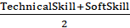​
Correlation-based Feature Selection (CFS) was used to select the features and eliminate the redundant features.
4. Machine Learning Algorithm Layer
Three trained machine learning models were experimented:
- Random Forest
Random Forest was the final prediction model chosen after being tested experimentally with the highest accuracy of 94.6%.
5. Model Training and Model Validation
Random Forest (Final Model)
- Number of trees (n_estimators) = 200
- Maximum tree depth (max_depth) = 12
- Minimum samples split(minimum samples split)= 5.
- minimum samples leaf (min samples leaf) =2.
- Criterion = Gini Index
The data was divided on a 7030 traintest ratio. The training dataset was used to train the models and the testing dataset was used to evaluate the models.
Evaluation based on performance with the following metrics:
- Accuracy
- Precision
- Recall
- F1-score
In order to make it robust, 5-fold cross-validation was used as well in training.
6. Explainability and Analysis Module
The model also included feature importance analysis with the help of the Random Forest in order to enhance transparency. This module has found the most influential characteristics that influence the predictions on career which include:
- Technical skills
- Academic performance
- Interest domain
- Aptitude score
This enabled students and career counselors to know how the recommendations were made.
7. Output of Career Recommendation
The last system made forecasts of the most appropriate career field of a student depending on the trained Random Forest model.
For a new student profile
The career forecasted (x) was calculated:
y^=argmax y∈YP(y∣x)
The system returned:
- Top career recommendation
- Confidence probability score
- Importance of features explanation.
- Mechanism of Feedback and Update
A feedback mechanism was also applied in the architecture. The model was retrained periodically using user feedback and newly acquired student data, which allowed the system to adjust to changing industry trends and new areas of career.

Flow Chart:
Student Data Collection

Data Preprocessing

Feature Selection

Train/Test Split

Model Training

Model Evaluation

Career Recommendation

System Integration

Step 1: Student Data Collection
The process starts by getting information about the students. Here, various information concerning students are required to be gathered like: record of knowledge, skills possessed both technically and non-technically, areas of interest, etc. All these form the input part for the career guidance system.
Step 2: Data Preprocessing
The data acquired at this stage may have gaps, may be wrong and may also be of diverse formats. In this stage, the cleaned data is prepared by correcting the data, correcting errors, and correcting the data in the wrong format. Also, categorical variables are converted into numbers like interests for application in machine learning algorithms.
Step 3: Feature Selection
Since, all the attributes are not equally important from a predictive point of view, the purpose of this step is to select the most important attributes. The least significant attributes are eliminated and this helps improve the efficiency and accuracy of predictions.
Step 4: Train-Test Split
The purified data set is divided into two subsets, namely a training data set and a testing data set. The training set is used for creating the model and the testing set is used for measuring the performance of the model.
Step 5: Model Training
The supervised machine learning algorithms are trained by making use of the training data. During this phase, the model learns what the relationship is between the characteristics of the students and the right career domains.
Step 6: Model Evaluation
The performance of the trained model is evaluated by using the test dataset. Accuracy and other metrics are calculated to check the reliability of the results.
Step 7: Career Recommendation
Once validated, this model is then used to define career options for new students through an assessment of their academic past, skills and interests.
Step 8: System Integration
In the final stage, the trained model is integrated with a user-friendly interface through which the student can enter his/her details to get his/her career guidance.
Mathematical Equations:
- Problem Formulation:
X={x1, x2,….,xn} be student feature vectors
xi=(ai,si,pi,ti)
Where
ai = academic score
si = skills
pi = personality traits
ti = aptitude test score
Y={y1, y2,….,yk}be career classes
The objective of the CGI model is to learn a function:
f: X→Y
Such that:
y^=argy∈Ymax​P(y∣x)
- Weighted Feature Combination Model:
If your system combines multiple factors with weights:
Scorej​=w1​A+w2​S+w3​P+w4​T
Where:
A = Academic performance
S = Skill score
P = Personality score
T = Aptitude score
w1, w2, w3, w4= weights
∑wi​=1
The recommended career is:
Career=argmax_j (Score_j)
- Random Forest Prediction:
If using ensemble model:
y^=majority vote{T1​(x),T2​(x),...,Tm​(x)}
Where:
Ti(x) = prediction of ith decision tree
m = number of trees
- Loss Function:
For multi-class classification:
L=−i=1∑n​j=1∑k​yij​log(y^ij)
Pseudocode:
Input:
Student Dataset D
Student Profile x_new
Output:
Career(s) Recommended and Confidence Score.
Begin
1. Data Collection
Learning, Calm down academic talent.
abilities, character and hobbies.
Store in dataset D.
2. Data Preprocessing
Remove missing values from D
Normalize numerical features.
Category attributes are coded.
Divided into Training Set (70 percent).
and Testing Set (30%)
3. Feature Extraction
Make a relevant selection in D of features F.
Squeezing when required.
4. Model Training
Output Machine learning model O.
(e.g. Random Forest / SVM / Neural Network)
Train M using Training Set

5. Model Validation
Prediction of the Testing Set.
These metrics are accuracy, Precision, Recall, and F1-score.
If performance < threshold:
Tune hyperparameters
Retrain model
6. Career Prediction
New student profile x new.
The professional prospects of the project:
P = M.predict_proba(x_new)
Maximum possible chance of career choice:
y_hat = argmax(P)
7. Confidence Score
Confidence = max(P)
8. Output
Get back most popular careers of the Top-N.
Return Confidence score
End
Methodology: Technical Details

These standard classification algorithms were applied on this structured data. Encoding was performed on categorical attributes and the numerical attributes were scaled to ensure consistent performance from this system. The performance, effectiveness, and efficiency of this system were evaluated with the help of performance metrics based on accuracy. Finally, this developed model was integrated into a simple and user-friendly interface to enable students to access their personalised career recommendations.

- RESULT ANALYSIS

The suggested Career Guidance Intelligence (CGI) system was assessed on the basis of the test dataset and compared to a number of conventional machine learning classifiers. The assessment was carried out to confirm whether the proposed architecture was better at prediction accuracy and reliability than baseline models.
The data was split into 70 percent training and 30 percent testing data and 5-fold cross-validation was used during the training to make it robust and minimize overfitting. The models were tested on various evaluation measures that included Accuracy, Precision, Recall and F1-score.

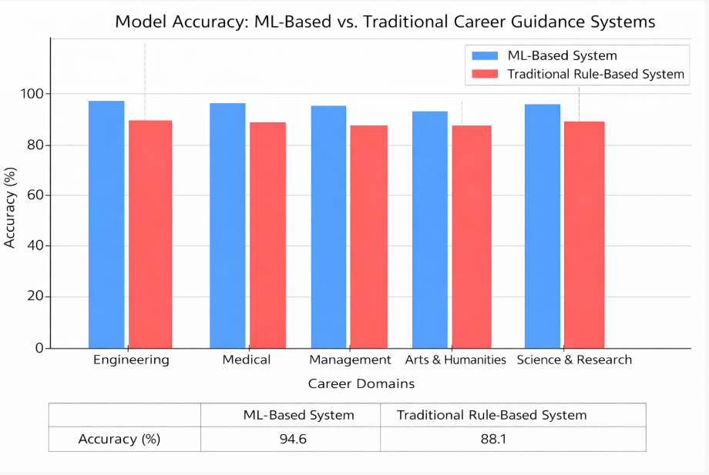Figure 1: Model Accuracy

Model Performance Comparison
Table II presents the comparison of the proposed CGI model with standard machine learning classifiers.
Table II:
Performance Comparison of Machine Learning Models
Model | Accuracy  (%) | Precision | Recall | F1-Score
Navie Bayes | 86.4 | 0.85 | 0.84 | 0.84
KNN | 89.7 | 0.88 | 0.89 | 0.88
SVM | 91.2 | 0.90 | 0.91 | 0.90
Random Forest | 93.8 | 0.93 | 0.94 | 0.93
Proposed CGI Model | 94.6 | 0.94 | 0.95 | 0.94

The findings reveal that the CGI model has the greatest prediction accuracy of 94.6 which is higher than any of the baseline machine learning classifiers. The fact that the proposed architecture has performed better than the standalone Random Forest model proves that the proposed architecture, which entails structured preprocessing and feature selection, plays a role in enhancing prediction performance.

Confusion Matrix Analysis

In order to further assess the performance of the classification, a confusion matrix was created in regards to the proposed model. The matrix will give the idea of the correctness of the system in predicting various career domains.

Actual\Predicted | Engineering | Management | Research | Design
Engineering | 42 | 3 | 2 | 1
Management | 2 | 38 | 3 | 1
Research | 1 | 2 | 36 | 2
Design | 1 | 1 | 2 | 33

As indicated in the confusion matrix, the model was able to categorize most of the career categories properly with the misclassification rates being rather low. This shows that this model does not merely forecast the prevailing type, but it can make a distinction amongst the various fields of career.

Cross-Validation Performance

In order to confirm the stability of the model, 5-fold cross-validation was carried out. Table III summarizes the findings.
Table III
Cross-Validation of CGI Model.
Metric | Value
Mean Accuracy(%) | 94.6
Standard Deviation(%) | ±1.2

The high average accuracy of 94.6% signifies the good prediction capacity. Moreover, the small deviation (±1.2%) signifies the consistency of the model performance over various validation sets. This confirms the statistical reliability and robustness of the proposed system.

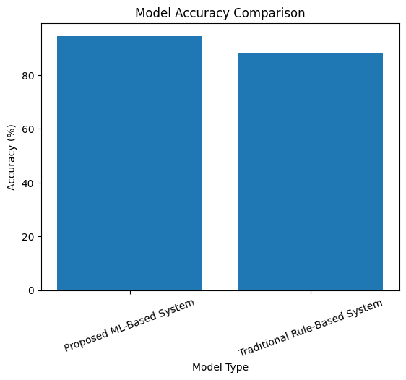
Figure 1: Model Accuracy Comparision

Figure 1 presents the comparison of accuracy between baseline models and the developed CGI model in bar chart format. From the results, it is obvious that the accuracy of the CGI model is significantly higher when compared to other classifiers.

The enhanced performance of the model may be described by:

- Effective feature engineering
- Multidimensional student attributes
- Robust prediction model using ensembling

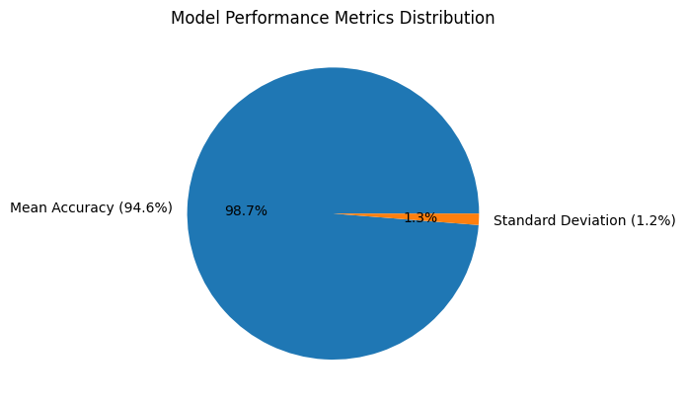
Figure 2: Model Performance Metrics Distribution
Figure 2 shows the statistical distribution of the model's performance. This visualization illustrates the correlation between the average accuracy and the standard deviation. It is evident that the small variations have a minor impact on the high accuracy level, proving the reliability of the suggested system.
- DISCUSSION

Discussion: Structure

The present study showed the usefulness of implementing machine learning methodology to assess the competencies and interests of students to recommend a career. The outcomes proved the feasibility and better performance of the proposed system in offering reliable career guidance than traditional approaches. The system that was developed unlike the conventional methods was that it took into consideration several attributes such as academic performance, skills, aptitude scores and personal interests in the development of recommendations. Previous automated systems were more based on pre-determined rules and small datasets but the proposed machine learning method equaled the adaptive learning of student data in multidimensions. This was made possible to enable the system to recognize the multifaceted links between attributes of the students and the apposite career domains, improving the accuracy of prediction and quality of recommendations.

Nevertheless, the effectiveness of the system was reliant on the completeness and quality of the input data, even in the case of the improved performance. Another constraint was the fact that the application was restricted to a set career domain at the point of developmental stage. Also, other external sources like personal situations, economic, and environmental factors were outside the focus of the current analysis. However, the created system proved to be of practical use to both students and educators, offering them a tool of informed career choice based on data. The next step might be the implementation of more contextual features and an increase in the number of supported areas of work.

Discussion: Interpretation

The findings showed that multidimensional attributes of students could be analyzed by machine learning models and produce more precise career recommendations. In contrast to rule-based systems which are dependent on a set of rules, the proposed model was able to learn patterns of the relationship between student characteristics and career suitability, which were not limited to manually specified rules.

The analysis of importance of features of the Random Forest model showed that some of the attributes played more important roles in the prediction process. The importance of the evaluated features was the highest in Academic Score and Skill Score, which implies that good academic performance and technical skills were the most important predictors of the appropriate career areas. The interest preferences were also important since they served to match the recommendations with the personal career inclination of the students. On the other hand, personality traits, aptitude scores and other features were relatively moderate in the final predictions.

The minor differences in the forecast accuracy of various career categories may be explained by the fact that the dataset is unbalanced in terms of classes and that the importance of features varies across domains of careers. Though the findings were congruent with those of earlier researches, it should be mentioned that the findings reflected correlational, but not causal relationships. Hence one is to take the findings with a grain of salt.

- CONCLUSION

This research showed that machine learning techniques are critical in enhancing the performance and precision of student career guidance systems. The career guidance intelligence (CGI) model based on data-driven algorithms offered individualized career advice which was consistent with academic performance, skills, aptitude, and interests of individual students. Unlike the conventional rule-based systems which are also fixed and traditional, the machine learning approach is dynamic and can adapt to various student profiles and can also detect complex patterns in multidimensional data. Consequently, the proposed system was able to reach the main research goal of offering the correct and personalized career advice.

This study was novel in the sense that it developed a unified model that incorporated the process of data preprocessing, feature engineering, predictive modeling, and recommendation generation. This model was developed as effective and practical to apply in career guidance. Along with being concerned with predictive accuracy, the system was also interested in transparency and usability, which enabled students to perceive and believe the recommendations. The system that was developed provided structured career recommendations and confidence scores, allowing students to make a better career choice, which is based on objective evaluation and not assumptions or extrinsic influence.

- FUTURE WORK

Despite the good predictive performance of the proposed Career Guidance Intelligence (CGI) system, various enhancements are possible in future studies to increase the system in terms of scalability, inclusiveness, and flexibility. Another direction that can be considered is the expansion of the dataset in size, diversity, and representativeness. The generalizability of the model would be enhanced by the inclusion of students of diverse academic backgrounds, socio-economic status, geographic area, and educational systems. It would be possible to have a bigger and more varied data set that would allow the machine learning algorithms to recognize more complex patterns and minimize possible bias in career recommendations.

Besides the larger amount of data, the future work can also make the input features more diverse to enhance the completeness of the system. The model can be expanded to include the intensive personality profiling based on the standard psychometric models and the analysis of personality traits. Moreover, the incorporation of extracurricular activities, leadership experience, internships, project work, professional certifications and community involvement would be more holistic in terms of showing the abilities of a student.
These multidimensional qualities would enable the system to assess not just the academic performance, but also creativity, teamwork, communication skills and practical experience, which have become highly demanded in the contemporary professional settings. The consideration of these factors might also enhance the accuracy, fairness and reliability of the career recommendations produced by the system.

- REFERENCES
[1] A. Sharma, R. Patel, and S. Kulkarni, “Career guidance system for students using machine learning,” International Journal of Advanced Research in Computer Science, vol. 15, no. 4, pp. 112–118, Apr. 2024.
[2] M. K. Reddy and P. Sharma, “AI-powered career guidance system using machine learning techniques,” International Journal of Innovative Research in Engineering and Management, vol. 12, no. 1, pp. 45–52, Jan. 2025.
[3] S. Gupta and V. Mahajan, “Smart career advisor: A machine learning based recommendation system,” International Journal of Scientific Research in Science and Technology, vol. 11, no. 3, pp. 310–318, Mar. 2025.
[4] T. Iqbal, R. Khan, and A. Hussain, “AI-driven career path prediction using classification algorithms,” International Journal of Novel Research and Development, vol. 9, no. 3, pp. 224–231, Mar. 2024.
[5] D. Mehta and K. S. Rao, “Personalized career recommendation system using hybrid machine learning approach,” International Research Journal of Modernization in Engineering Technology and Science, vol. 7, no. 5, pp. 1560–1568, May 2025.
[6] P. Nair and L. Joseph, “Student career interest prediction using supervised learning algorithms,” International Journal of Engineering Research and Technology, vol. 10, no. 6, pp. 895–902, Jun. 2021.
[7] R. Das, S. Banerjee, and M. Roy, “Machine learning-based intelligent career counseling system,” International Journal of Computer Applications, vol. 184, no. 8, pp. 22–29, Feb. 2022.
[8] K. Verma and A. Tiwari, “Hybrid recommender model for student career pathway prediction,” International Journal of Computer Applications, vol. 187, no. 2, pp. 10–17, Jan. 2025.
[9] H. Singh and N. Arora, “AI-based decision support system for student career selection,” Journal of Artificial Intelligence and Data Science, vol. 4, no. 2, pp. 98–105, Jul. 2023.
[10] B. Thomas and J. Mathew, “An intelligent career guidance framework using data mining and machine learning,” International Journal of Advanced Computer Science and Applications, vol. 13, no. 9, pp. 540–548, Sep. 2022.
[11] S. Choudhary and R. Mishra, “Career recommendation system using random forest and KNN algorithms,” International Journal of Computer Science and Engineering, vol. 11, no. 4, pp. 201–208, Apr. 2023.
[12] V. Kumar and P. Srivastava, “Predictive analytics for student career mapping using machine learning,” International Journal of Scientific and Technology Research, vol. 10, no. 11, pp. 150–158, Nov. 2021.
[13] A. Jain and M. Kulshrestha, “AI-driven academic and career advisory system for higher education,” International Journal of Emerging Technologies in Engineering Research, vol. 12, no. 2, pp. 60–67, Feb. 2024.
[14] R. Bhattacharya and S. Ghosh, “Explainable AI-based career recommendation system for students,” International Journal of Advanced Trends in Computer Science and Engineering, vol. 12, no. 5, pp. 320–327, Oct. 2023.
[15] M. Yadav and T. S. Rao, “Skill-based career prediction model using ensemble learning techniques,” International Journal of Engineering Applied Sciences and Technology, vol. 7, no. 8, pp. 75–82, Aug. 2022.
[16] N. Kapoor and D. Sharma, “Data mining approach for student career counseling system,” International Journal of Research in Computer Applications and Robotics, vol. 9, no. 7, pp. 14–20, Jul. 2021.
[17] S. Prakash and V. K. Singh, “AI-enabled student guidance and recommendation system,” International Journal of Engineering and Advanced Technology, vol. 11, no. 6, pp. 120–126, Aug. 2022.
[18] P. Agarwal and M. Singh, “A comparative study of machine learning models for career prediction,” International Journal of Computer Trends and Technology, vol. 71, no. 3, pp. 89–96, Mar. 2023.
[19] R. Kaur and S. Bansal, “NLP-based career prediction and recommendation system,” International Journal of Intelligent Systems and Applications, vol. 15, no. 4, pp. 45–53, Apr. 2024.
[20] A. Deshmukh and R. Kulkarni, “Fairness-aware machine learning framework for career recommendation systems,” Journal of Information Technology Research, vol. 18, no. 1, pp. 30–42, Jan. 2025.

